User Reference Document – Affiliated Colleges Enterprise Portal

RR

SAP Implementation At M D University Rohtak
By KPMG Professional Services
Error! No document variable supplied.
Date : 01.09.2015



Maharashi Dayanand University, Rohtak
(Established under Haryana Act No. 25 of 1957)
(‘A’ Grade NAAC Accredited)

Getting Logged On to MDU Enterprise Portal

- Switch ON your PC. A screen similar to the one shown below will flash on your PC: [Desktop Screen]

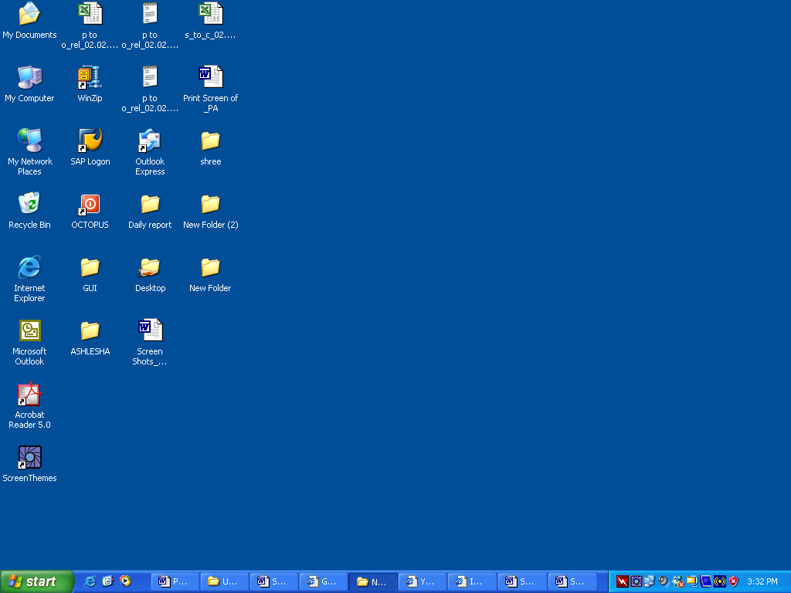

- Open Google Crome/Internet Explorer (preferably IE 11) and open the below mentioned link.

MDU Enterprise Portal Link: http://e-rishi.mdurtk.in

Logging into MDU SAP Enterprise Portal

- Once you open the above mentioned link, a similar window will appear. It is the login screen of M D University SAP Enterprise Portal – Affiliated Colleges

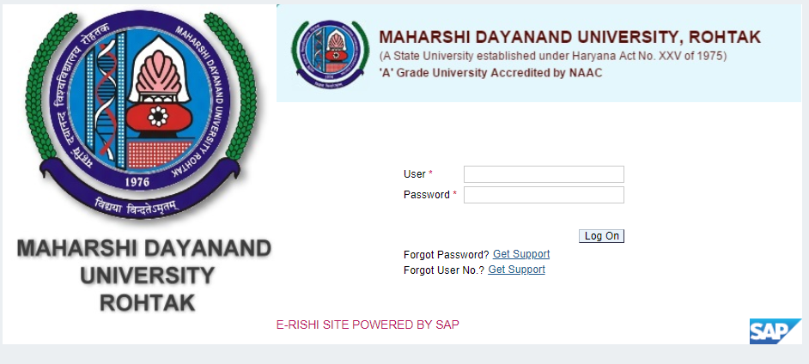

- Kindly log-in using the User ID and Password provided to the college by M D University
Please note: Password is case sensitive

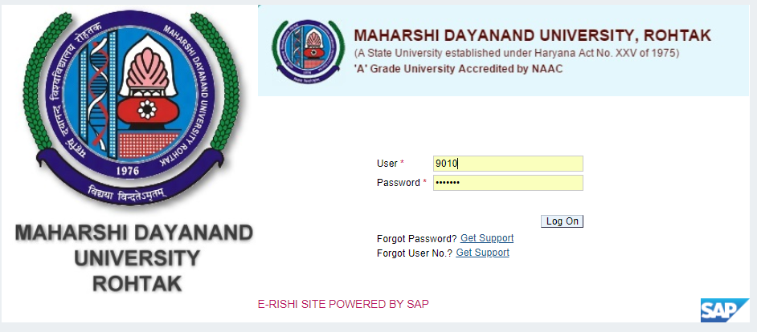

Press “LOG ON” button after inserting User ID and Password.

Student Continuous Registration

Affiliated colleges can perform continuous registration for their students in this link.
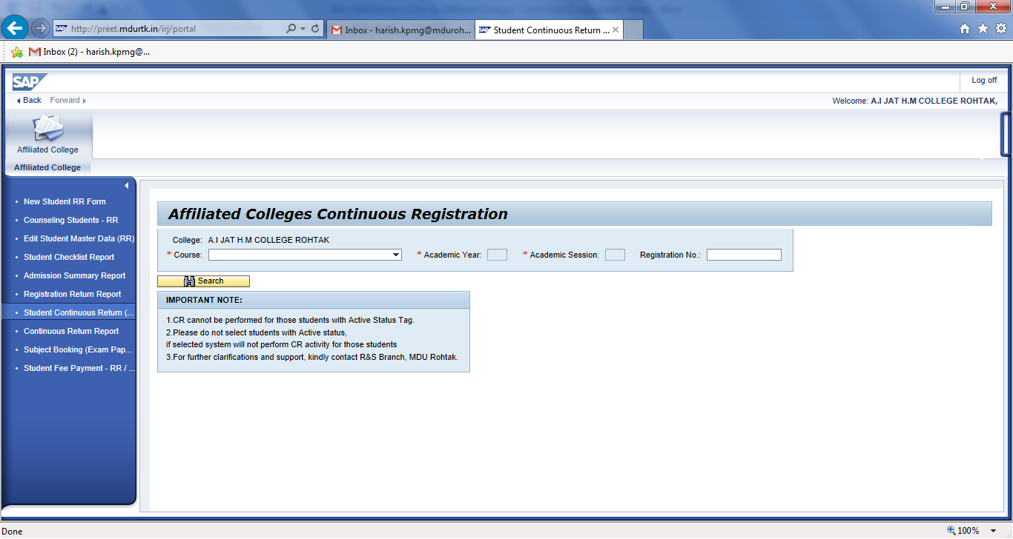
Select the desired values from the dropdown provided in selection screen and click on button.
Kindly input CR student’s “Registration Number” for faster search in this below column:
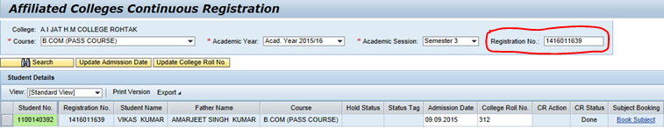

Users are requested to check for student status tag, CR cannot be performed for the student who is having “Active” status tag.
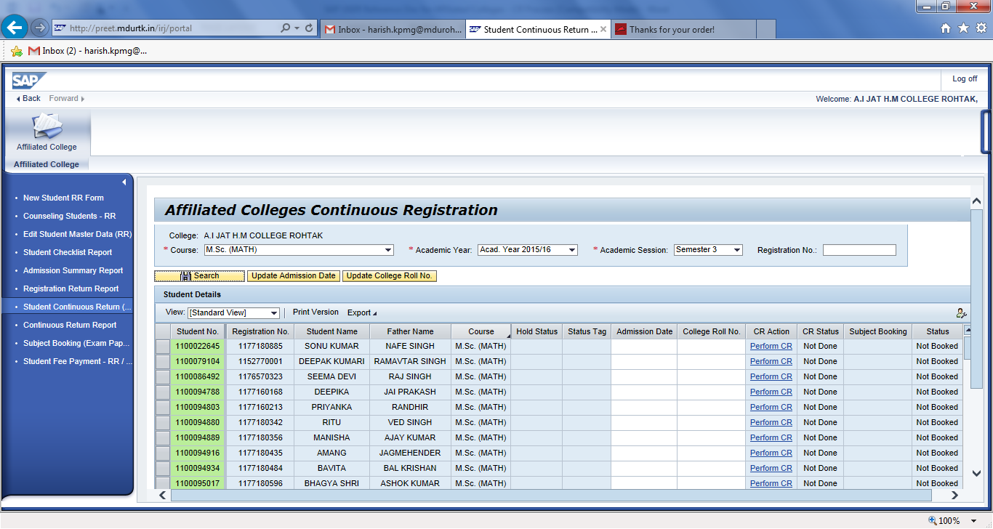
You are required to process CR students one at a time, as they are supposed to do subject booking also for the selected student at the same time.
As first step select the student for which CR has to be performed.
Upon selecting the student, input Admission Date and College Roll Number as desired for the respective student. After input press the button ‘Perform CR’.
This registers the selected student to the respective semester (CR)
Once CR is successful for the student, an message is displayed at top of the screen.
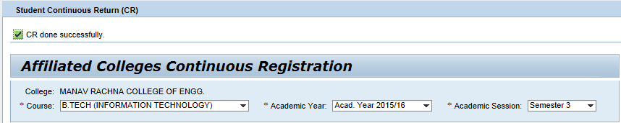

In case user is required to edit ‘Admission Date’ or ‘College Roll Number’, kindly use “UPDATE” buttons provided in the screen. But kindly ensure to select the respective student before editing the values.
Once update is successful, a message is displayed at the top of screen.

Now users can proceed with subject booking for the same student, by clicking on

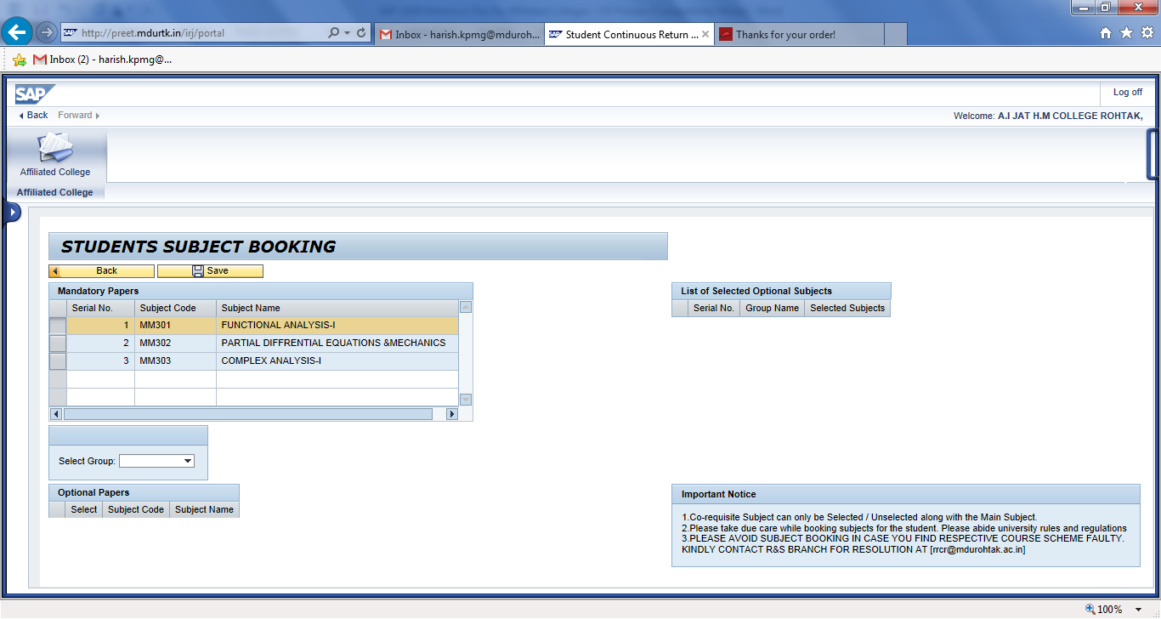
Users are required to select the Subject Group (if existing). If groups are not existing, you can just click on button to save the mandatory subjects.
In case groups exist for a particular course and user is required book subjects belonging to group, he can select the corresponding available groups here.
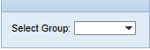
Users can have clear idea on status of student subject booking by the using the box in the screen.
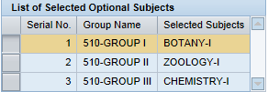
Once subject booking is done with all the desired groups, please click on to book selected subjects for the respective student.
Once data is saved successfully, system will intimate the user by a message.
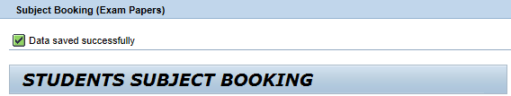

Once subject booking is completed for the respective student, kindly press button for processing next student in CR application.

While executing CR application, users can easily track the student’s activity status in the below mentioned screen fields.
When CR has not yet performed, it will show as 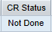
When Module (Subject) booking is not performed, it will show as 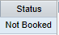
When CR has been performed for the selected student, it will show as 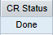
When Module Booking has been performed, it will show as 