User Reference Document – Affiliated Colleges Enterprise Portal

RR

SAP Implementation At M D University Rohtak
By KPMG Professional Services
Error! No document variable supplied.
Date : 01.09.2015



Maharashi Dayanand University, Rohtak
(Established under Haryana Act No. 25 of 1957)
(‘A’ Grade NAAC Accredited)

Getting Logged On to MDU Enterprise Portal

- Switch ON your PC. A screen similar to the one shown below will flash on your PC: [Desktop Screen]

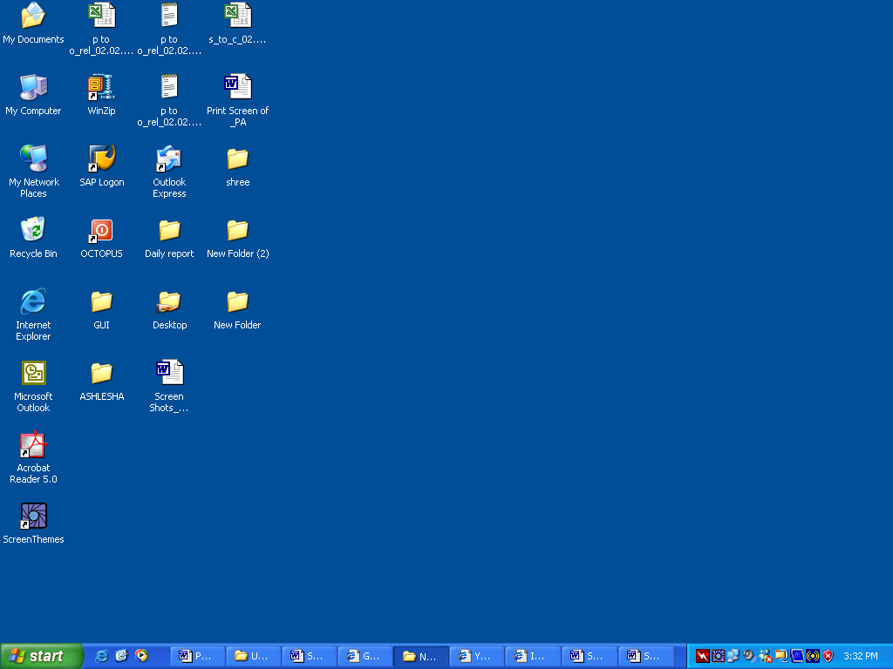

- Open Google Crome/Internet Explorer (preferably IE 11) and open the below mentioned link.

MDU Enterprise Portal Link: http://e-rishi.mdurtk.in/irj/portal/

Logging into MDU SAP Enterprise Portal

- Once you open the above mentioned link, a similar window will appear. It is the login screen of M D University SAP Enterprise Portal – Affiliated Colleges

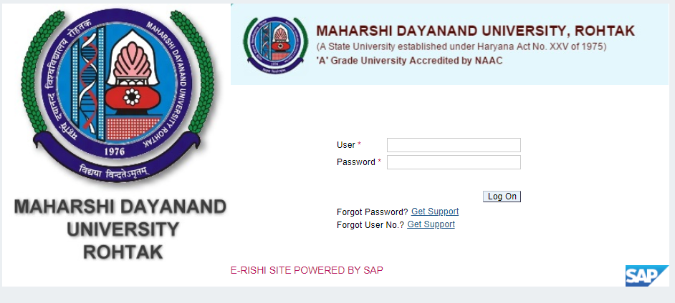

- Kindly log-in using the User ID and Password provided to the college by M D University
Please note: Password is case sensitive

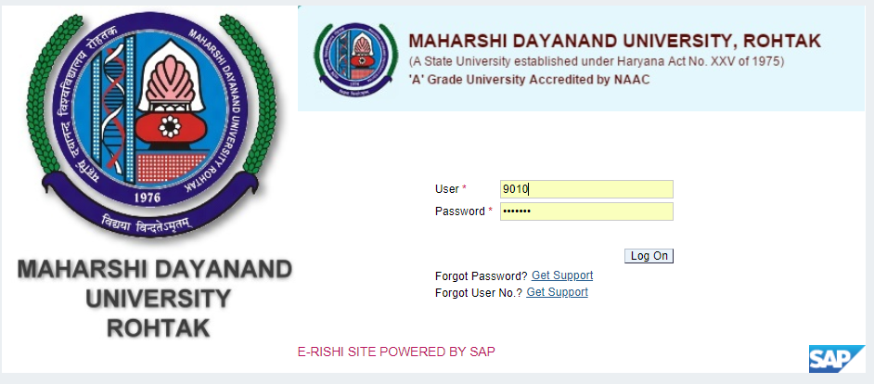

Press “LOG ON” button after inserting User ID and Password

Counselling Students – RR
[Applicable only for college/institutes who has students’ allotment under central counselling]
M D University will allot students to their respective college/institute in case of central counselling. Students will be created in the system along with course, year, semester, quota and student personal details. These details are displayed in non-editable mode for the respective affiliated college.
Respective affiliated college/institute can view, edit their allotted students in this service. They are required to fill in certain student master data such as student address, educational qualification and photo, signature, thumb impression. For performing Registration Return/Challan Generation, these details should be mandatorily filled by the respective college/institute.
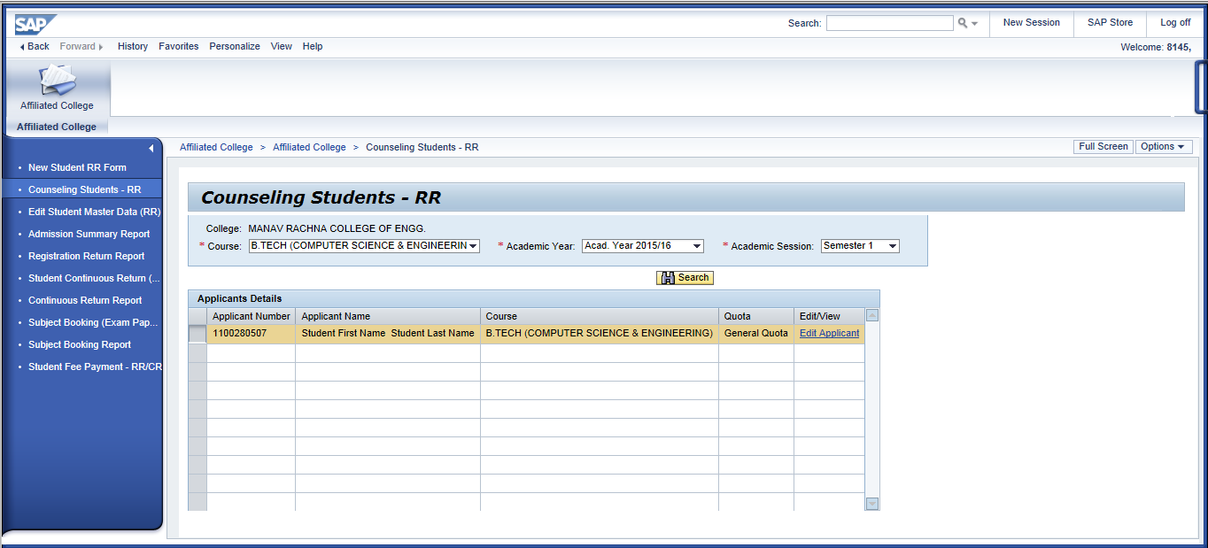
Users can search their students by input of course, academic year and semester from the dropdown provided in the screen.
Students are displayed after clicking “Seach” button and user can fill students’ details one by one by clicking on “Edit Applicant” button.
After clicking on “Edit Applicant” button, Registration Return form is presented to the user.
But user cannot edit course and personal details of the student, they can only edit/fill address, educational and image files of the student.
Student Course View: [Non-Editable]
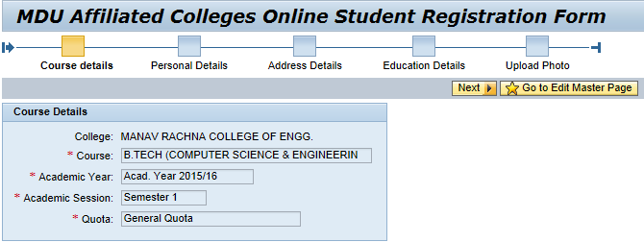
Student Personal Details View: [Non-Editable]
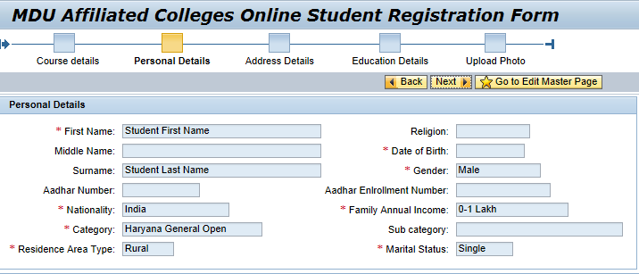

Address Details: [Editable]
In this screen, user has to fill in student’s address details which forms part of student master data.
Please ensure the information you provide is with utmost accuracy and ensure it is free from typo errors.
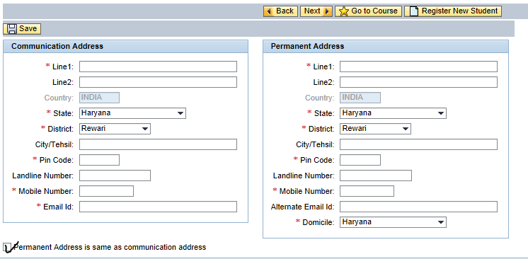
If student belongs to any other state other than “Haryana” then by default district field will be set to others.
SAMPLE:
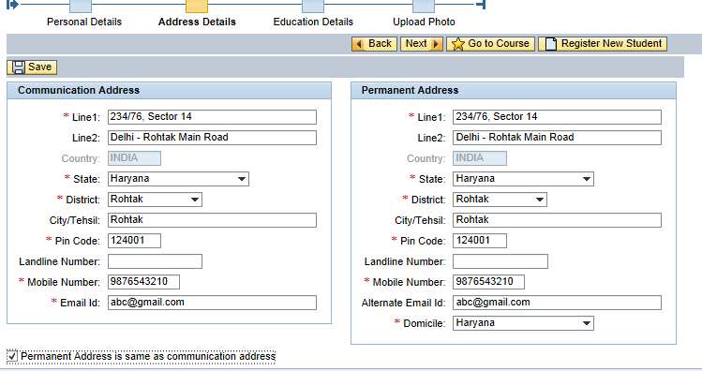
Please provide concerned student’s Mobile Number and E-Mail ID. Please avoid providing college/institute mobile and e-mail ID.
If permanent address is same as communication address, please click on below checkbox to activate the same as illustrated in the screen.
Once details are filled in the form, kindly press “SAVE” button which is on top left corner.
If data is saved, system will confirm you by a message.
After saving kindly click on “Next” button present in top left of the screen.
Educational Qualification Details: [Editable]
In this screen, user has to fill in student’s previous educational details which forms part of student master data.
Please ensure the information you provide is with utmost accuracy and ensure it is free from typo errors.
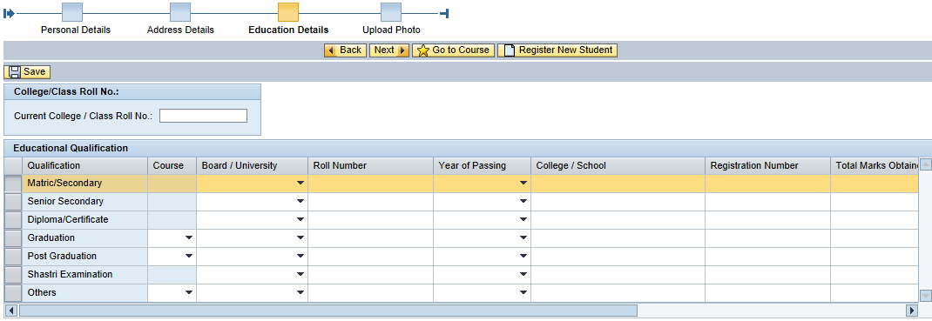

Kindly input current class roll number assigned to student by the college/institute in the respective column. It can be any number of digits or alpha numerical values.
Kindly input correct values in case of roll/registration number, any discrepancy in data will lead to serious concerns relating to student eligibility conditions.
For CBSC and HBSE students once board, roll number and year of passing is provided, system will automatically fetch rest of the details such as maximum marks, obtained marks and result status. (This provision is under testing, hence if no data is populated request you to manually input required details in respective fields)
SAMPLE:
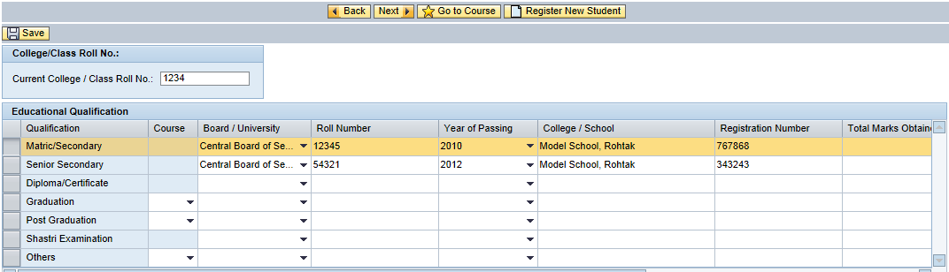
Scroll the below tab to view the next set of details in student educational details form.
Once details are filled in the form, kindly press “SAVE” button which is on top left corner.
If data is saved, system will confirm you by a message.
After saving kindly click on “Next” button present in top left of the screen.
Student Photo, Signature and Thumb Impression – Upload: [Editable]
Read the below instructions before uploading image files.
Please upload files in specified size, else system will not accept.
Instructions
1. PHOTO, SIGNATURE AND THUMB IMPRESSION ARE MANDATORY.
2. Press save button to save the data.
3. File should be in .JPG format only
4. Size of photo image should be upto 50 KB.
5. Size of Signature should be upto 30 KB.
6. Size of Thumb impression should be upto 50 KB.

If you click on “Browse” a new window will open from which you can select the desired file from your computer.
Please select the appropriate files and click on “SAVE”
SAMPLE:
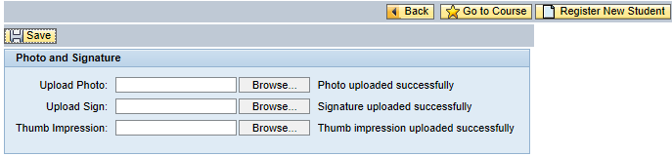
If upload is successful, system will display the successful message.
To update master data of next student, you are required to proceed to Edit Master Page by clicking on this icon - present in top right of the application.

Admission Summary Report

Admission summary report can be obtained by the college once fee is paid and subject booking is done for the respective students.
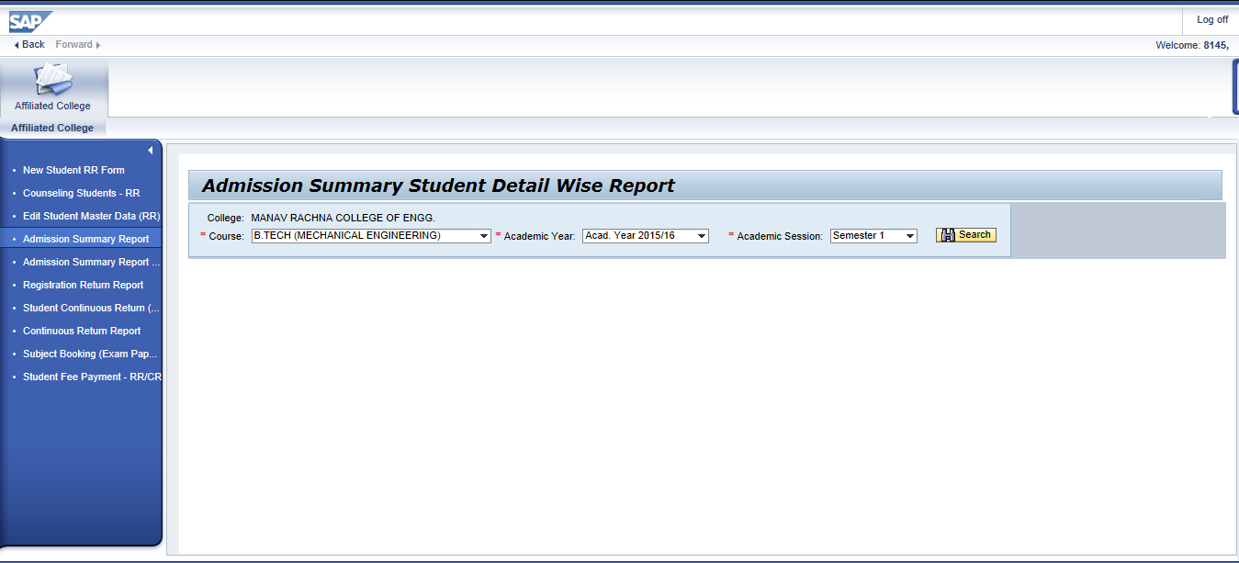
To obtain students is this report, college user should have got confirmation for the fees paid and subject booking should have been completed for those respective students.
Students for whom fees is not paid/confirmed or subject booking not done, will not be displayed in this report

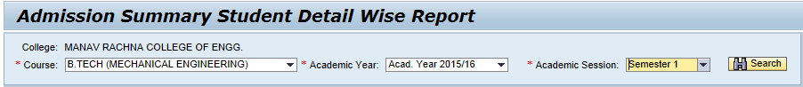
Select the desired values from the dropdown provided and click on button.
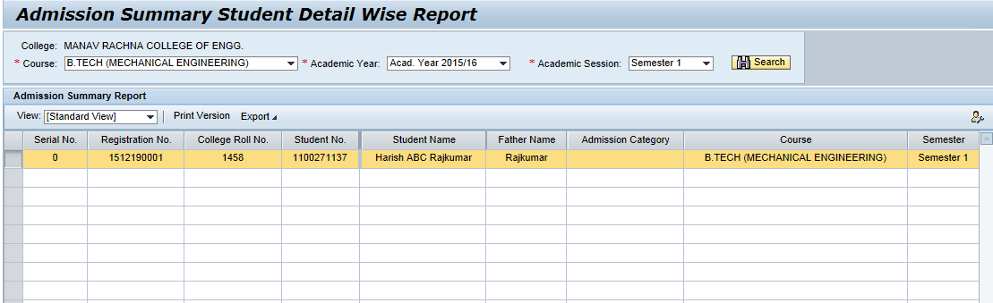

Students will be displayed accordingly.
For exporting the same to excel, click on and save the file to your computer.

Student Registration Report

Student Registration Report can be obtained by the college once fee is paid and subject booking is done for the respective students.
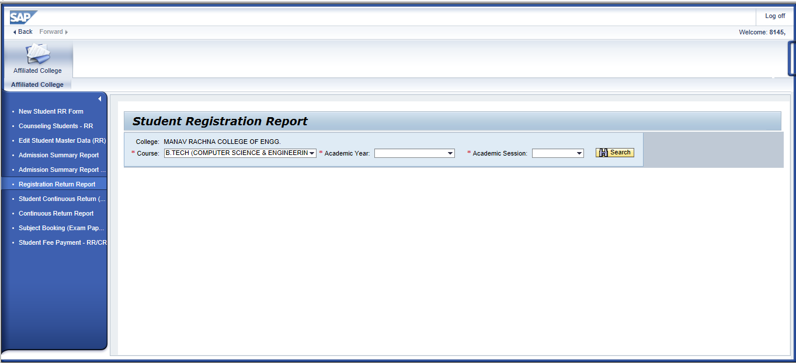
To obtain students is this report, college user should have got confirmation for the fees paid and subject booking should have been completed for those respective students.
Students for whom fees is not paid/confirmed or subject booking not done, will not be displayed in this report
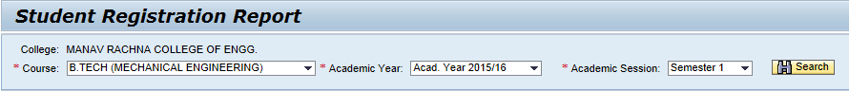
Select the desired values from the dropdown provided and click on button.
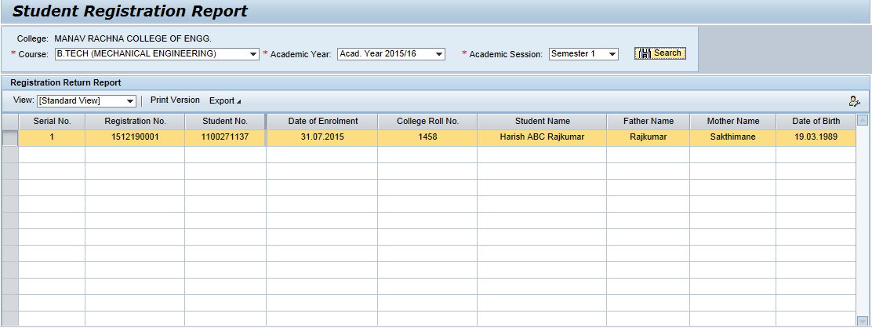
Students will be displayed accordingly.
For exporting the same to excel, click on and save the file to your computer.

