User Reference Document – Affiliated Colleges Enterprise Portal

RR

SAP Implementation At M D University Rohtak
By KPMG Professional Services
Error! No document variable supplied.
Date : 01.09.2015



Maharashi Dayanand University, Rohtak
(Established under Haryana Act No. 25 of 1957)
(‘A’ Grade NAAC Accredited)

Getting Logged On to MDU Enterprise Portal

- Switch ON your PC. A screen similar to the one shown below will flash on your PC: [Desktop Screen]



- Open Google Crome/Internet Explorer (preferably IE 11) and open the below mentioned link.

MDU Enterprise Portal Link: http://e-rishi.mdurtk.in/irj/portal/

Logging into MDU SAP Enterprise Portal

- Once you open the above mentioned link, a similar window will appear. It is the login screen of M D University SAP Enterprise Portal – Affiliated Colleges

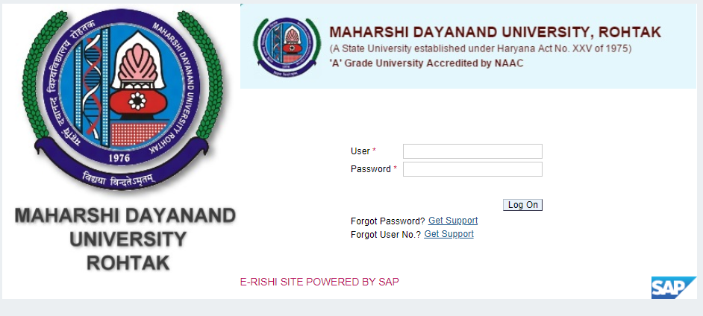

- Kindly log-in using the User ID and Password provided to the college by M D University
Please note: Password is case sensitive

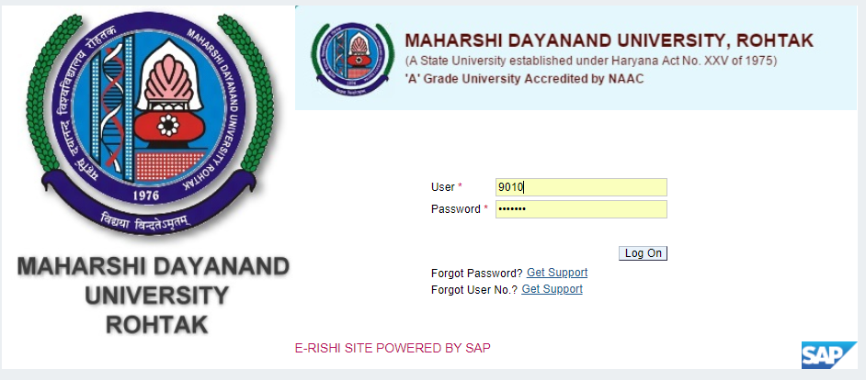

Press “LOG ON” button after inserting User ID and Password.

Student Fees Payment

Affiliated colleges can perform fee payment activity for their students in this link.
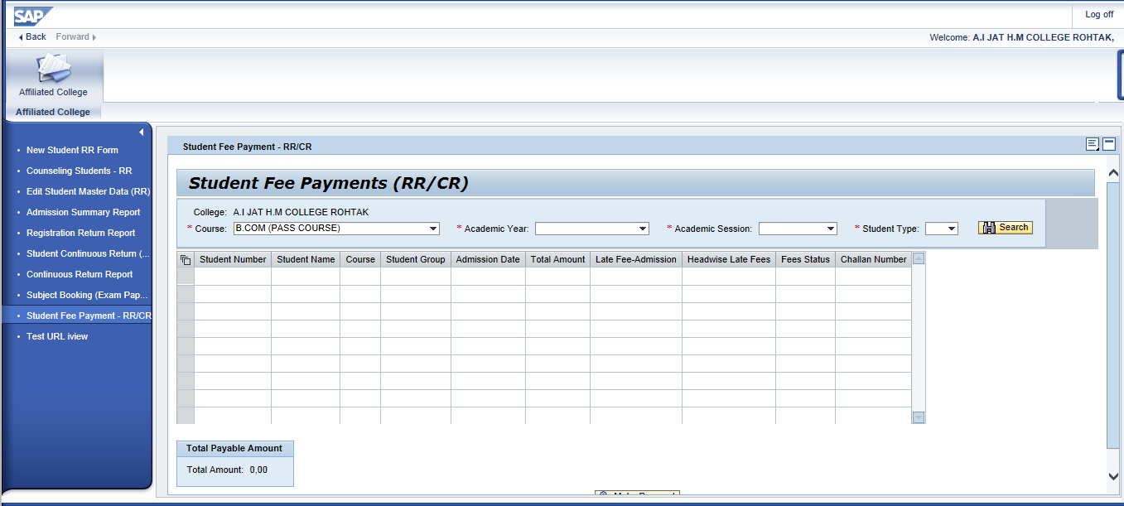

User are required to input appropriate data in selection parameter
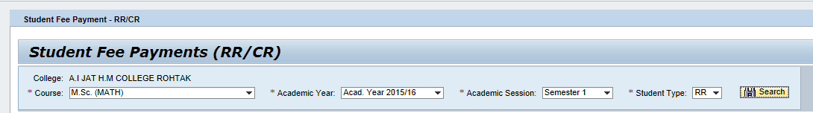
Select the desired values from the dropdown provided and click on button.

Select “RR” for New Registration Students and “CR” for Continuous Registration Students.
But please note RR can be selected either for 1st or 3rd semester only.
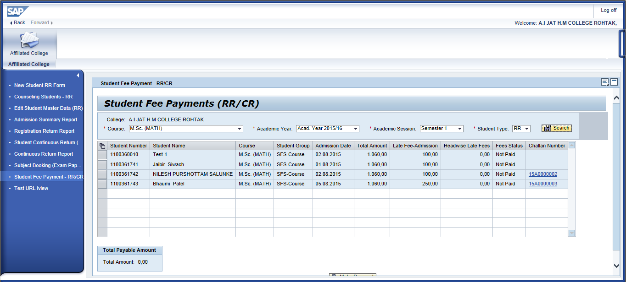
Users can have select all option in the above screen by pressing in the header tab. Multiple selection of students are also possible.
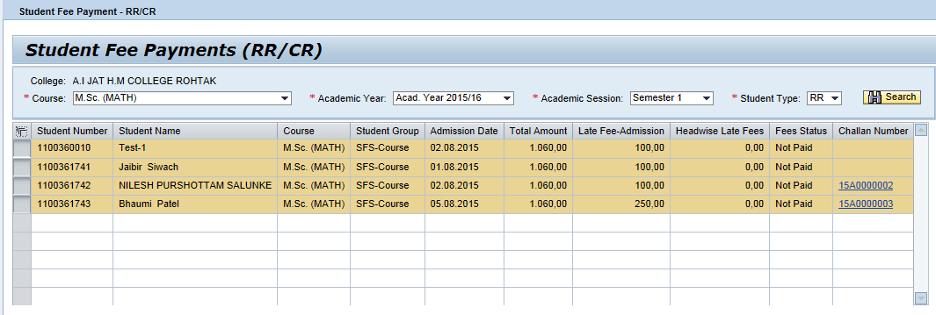
After student selection, press button to generate challan for the selected students along with student annexure.
Users can also have a provision to view their total challan amount in this box 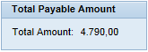
Challan:
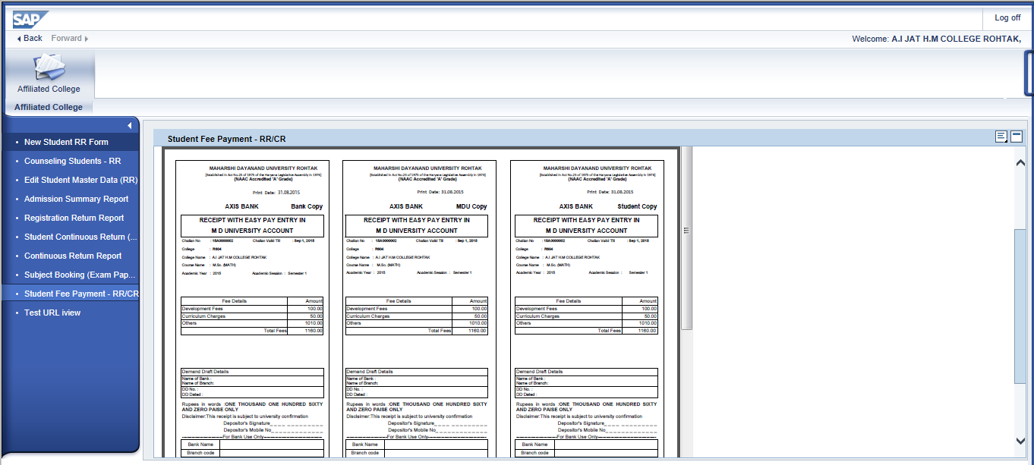
You can ‘SAVE’ or ‘PRINT’ directly with the options below

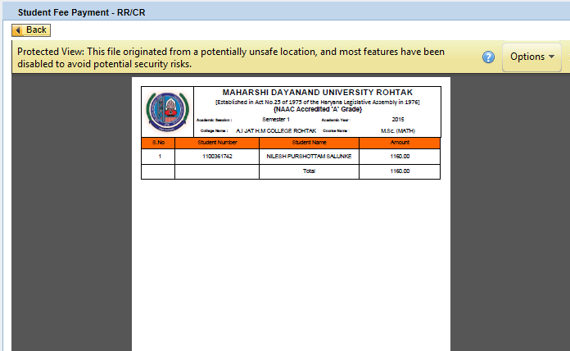

Student annexure for fee challan.

You are able to view the total students selected for the particular challan, their individual fees along with the total challan amount.

After generating the challan, college is required to remit the required fees in prescribed bank.
Once fees is confirmed by the bank against the challan, Fee paid status for those students will be change automatically to “Confirmed” status.
After fee confirmation, college users can obtain Admission Summary, RR & CR reports for their students.

