User Reference Document – Affiliated Colleges Enterprise Portal

RR

SAP Implementation At M D University Rohtak
By KPMG Professional Services
Error! No document variable supplied.
Date : 01.09.2015



Maharashi Dayanand University, Rohtak
(Established under Haryana Act No. 25 of 1957)
(‘A’ Grade NAAC Accredited)

Getting Logged On to MDU Enterprise Portal

- Switch ON your PC. A screen similar to the one shown below will flash on your PC: [Desktop Screen]

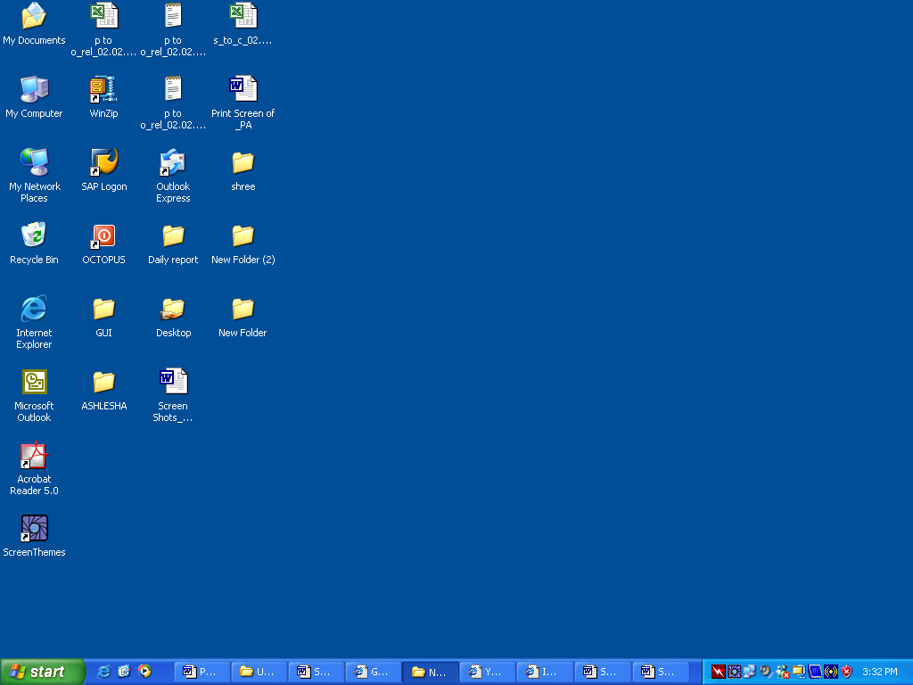

- Open Google Crome/Internet Explorer (preferably IE 11) and open the below mentioned link.

MDU Enterprise Portal Link: http://e-rishi.mdurtk.in/irj/portal/

Logging into MDU SAP Enterprise Portal

- Once you open the above mentioned link, a similar window will appear. It is the login screen of M D University SAP Enterprise Portal – Affiliated Colleges

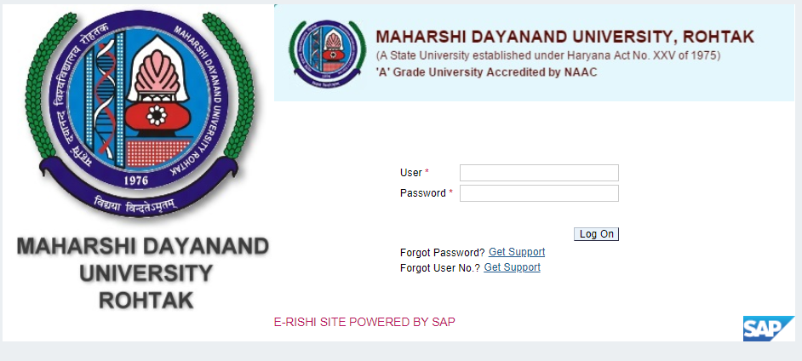

- Kindly log-in using the User ID and Password provided to the college by M D University
Please note: Password is case sensitive

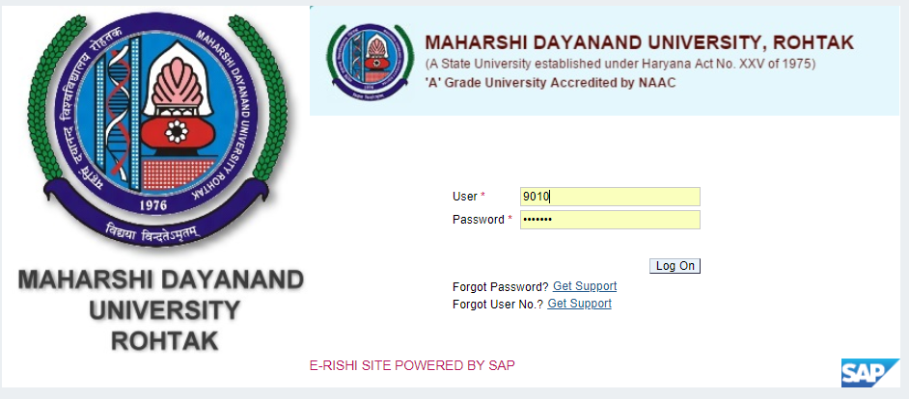

Press “LOG ON” button after inserting User ID and Password.

Student Module (Subject) Booking

Affiliated colleges are required to do subject booking activity for their students. Subject booking can be done using this link:
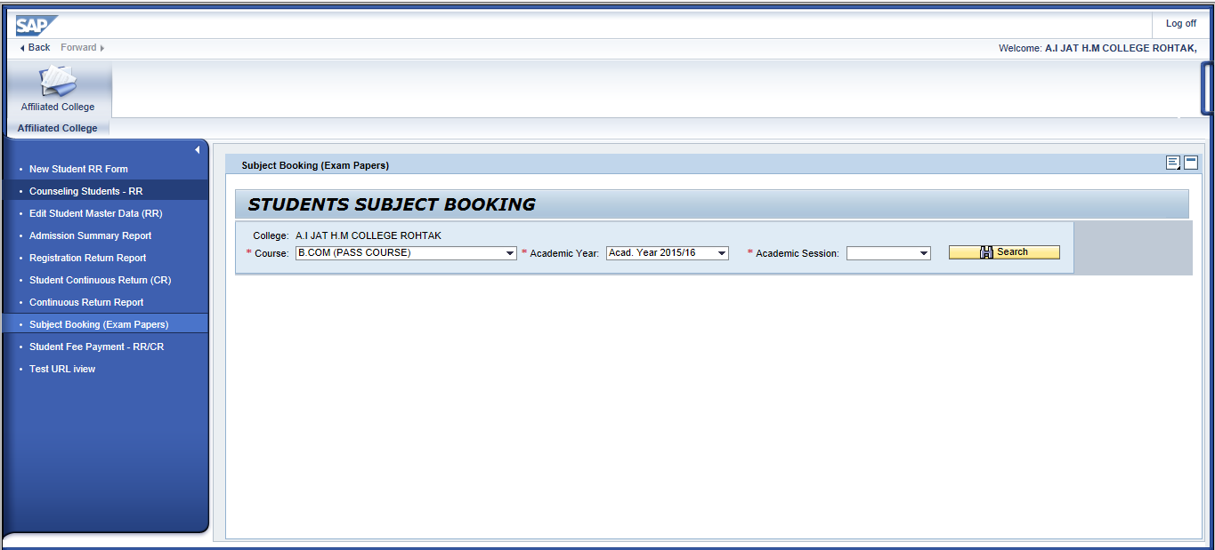
User are required to input appropriate data in selection parameter

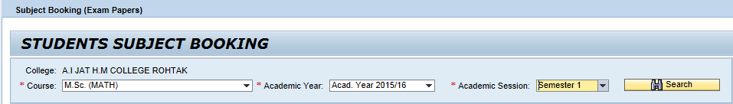
Select the desired values from the dropdown provided and click on button.

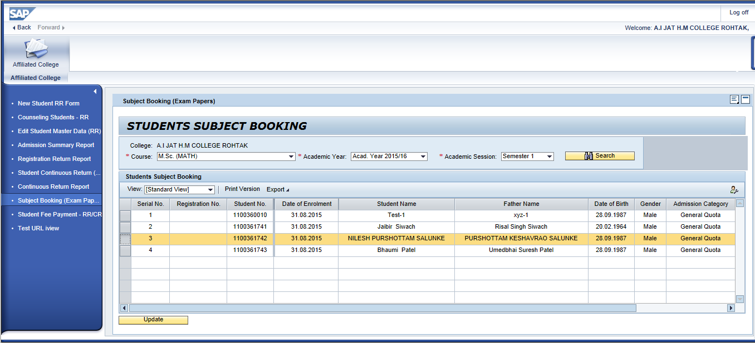

Users will be presented with list of students frm whom subject booking activity shall be performed.
Several search/filter options are available for selecting student. But subject booking activity can be performed one student per time.

Select the desired student from the screen and click on button to perform subject booking activity for the respective student.
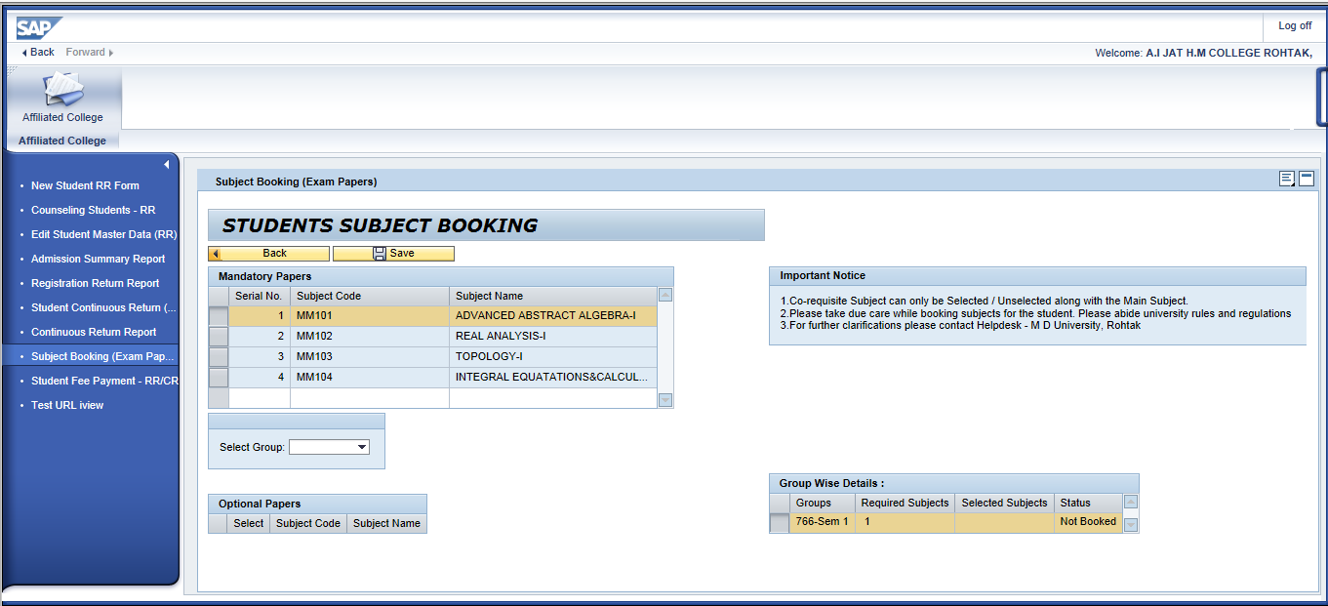
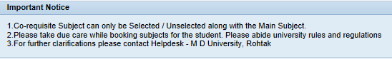
Users will not be able to edit any mandatory subject.
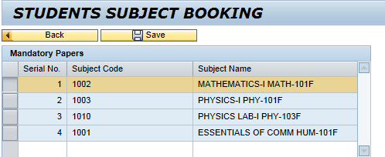

In case groups exist for a particular course and user is required book subjects belonging to group, he can select the corresponding available groups here.

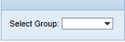
Users can have clear idea on number of available subject groups, required subjects and status of their booking by the using below mentioned box
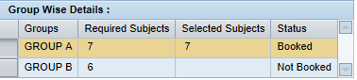

Once subject booking is done, please click on to book selected subjects for the respective student

Once data is saved successfully, system will intimate the user by a message.
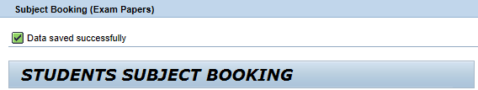

After that user can come back using and select next student for processing.

