User Reference Document – Affiliated Colleges Enterprise Portal

RR

SAP Implementation At M D University Rohtak
By KPMG Professional Services
Error! No document variable supplied.
Date : 01.09.2015



Maharashi Dayanand University, Rohtak
(Established under Haryana Act No. 25 of 1957)
(‘A’ Grade NAAC Accredited)

Getting Logged On to MDU Enterprise Portal

- Switch ON your PC. A screen similar to the one shown below will flash on your PC: [Desktop Screen]

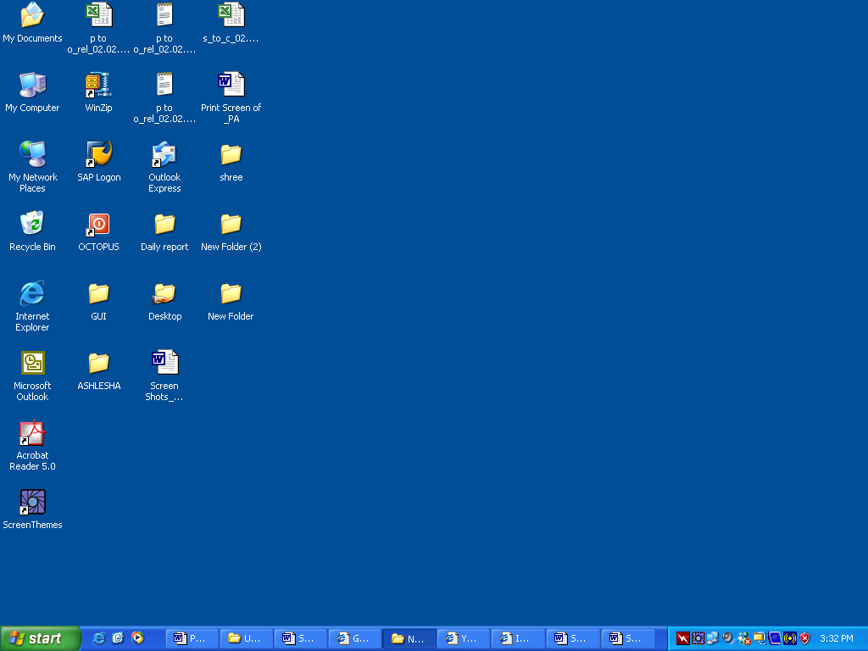

- Open Google Crome/Internet Explorer (preferably IE 11) and open the below mentioned link.

MDU Enterprise Portal Link: http://e-rishi.mdurtk.in/irj/portal/

Logging into MDU SAP Enterprise Portal

- Once you open the above mentioned link, a similar window will appear. It is the login screen of M D University SAP Enterprise Portal – Affiliated Colleges

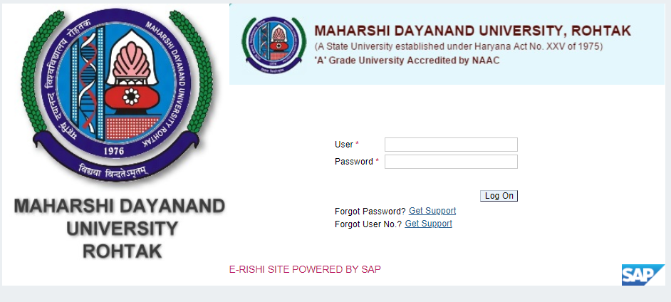

- Kindly log-in using the User ID and Password provided to the college by M D University
Please note: Password is case sensitive

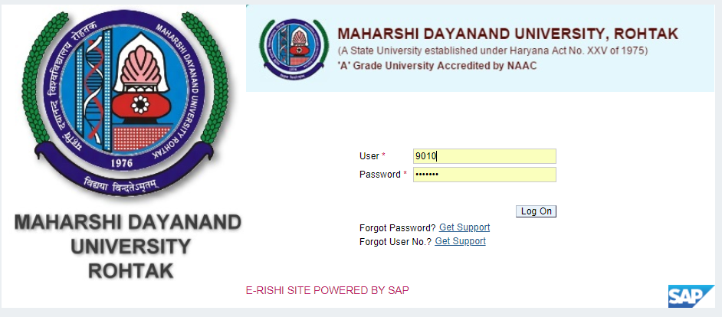

Press “LOG ON” button after inserting User ID and Password

New Student Registration Return Form (RR)

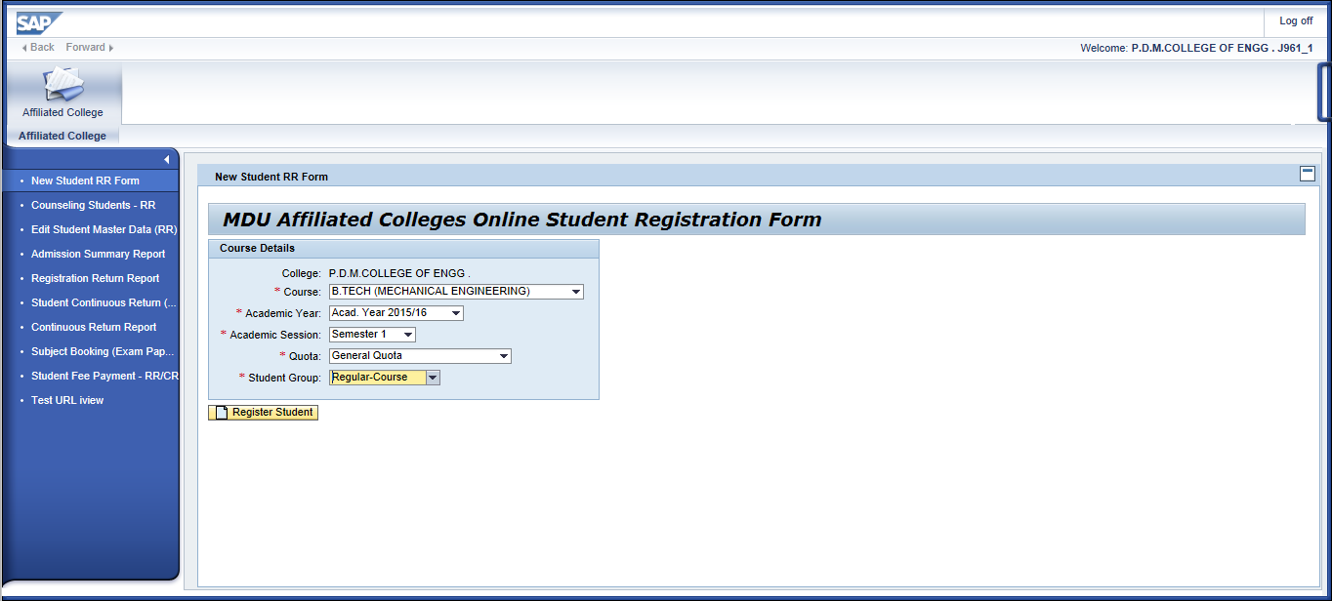
This link is used to create registration return of new students. When registering new students into system, user has to select course, academic year, semester and quota.
All the values would be available in dropdown, user has to select the appropriate values from dropdown. By default academic year would be containing the present year value.

For performing Registration Return, Subject Booking & Challan Generation, student master details should be mandatorily filled by the respective college/institute.

Please take due care while filling student master data.
Kindly fill in student details best of your knowledge.
Personal Details:
In this screen, user has to fill in student’s personal details which forms part of student master data.
Please ensure the information you provide is with utmost accuracy and ensure it is free from typo errors.
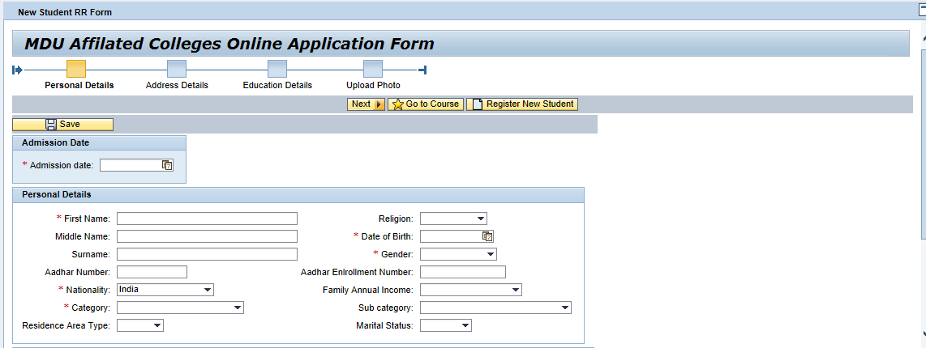

Kindly input student admission date. Based on this date fee will be calculated accordingly for the respective student/college.
If student maritial status is “Married” kindly enter spouse name in respective field.
Once details are filled in the form, kindly press “SAVE” button which is on top left corner.
If data is saved, system will confirm you by a message.
After saving kindly click on “Next” button present in top left of the screen.
Address Details:
In this screen, user has to fill in student’s address details which forms part of student master data.
Please ensure the information you provide is with utmost accuracy and ensure it is free from typo errors.
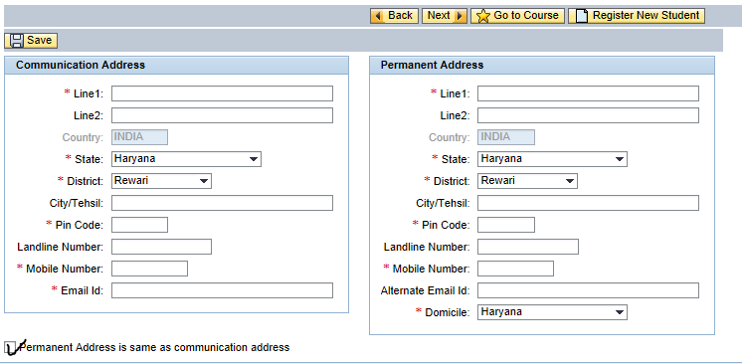
If student belongs to any other state other than “Haryana” then by default district field will be set to others.
SAMPLE:
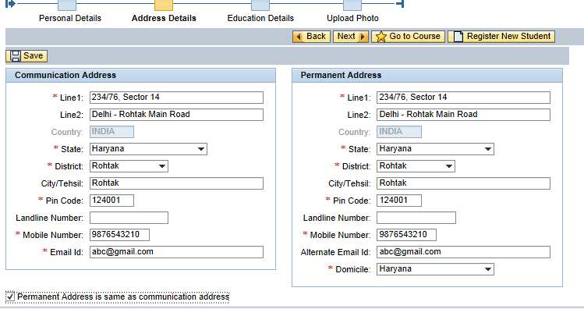
Please provide concerned student’s Mobile Number and E-Mail ID. Please avoid providing college/institute mobile and e-mail ID.
If permanent address is same as communication address, please click on below checkbox to activate the same as illustrated in the screen.

Once details are filled in the form, kindly press “SAVE” button which is on top left corner.
If data is saved, system will confirm you by a message.
After saving kindly click on “Next” button present in top left of the screen.
Educational Qualification Details:
In this screen, user has to fill in student’s previous educational details which forms part of student master data.
Please ensure the information you provide is with utmost accuracy and ensure it is free from typo errors.
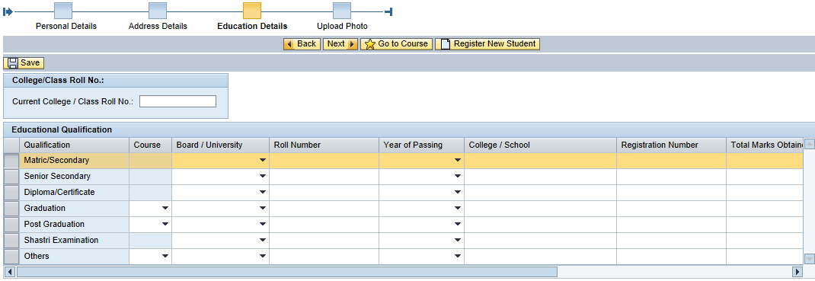
Kindly input current class roll number assigned to student by the college/institute in the respective column. It can be any number of digits or alpha numerical values.
Kindly input correct values in case of roll/registration number, any discrepancy in data will lead to serious concerns relating to student eligibility conditions.
For CBSC and HBSE students once board, roll number and year of passing is provided, system will automatically fetch rest of the details such as maximum marks, obtained marks and result status. (This provision is under testing, hence if no data is populated request you to manually input required details in respective fields)
SAMPLE:
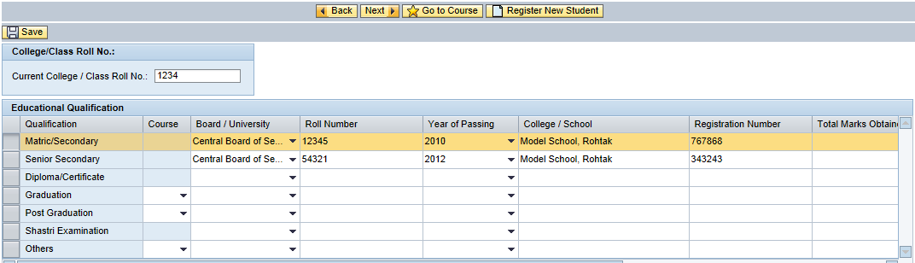
Scroll the below tab to view the next set of details in student educational details form.
Once details are filled in the form, kindly press “SAVE” button which is on top left corner.
If data is saved, system will confirm you by a message.
After saving kindly click on “Next” button present in top left of the screen.
Student Photo, Signature and Thumb Impression – Upload:
Read the below instructions before uploading image files.
Please upload files in specified size, else system will not accept.
Instructions
1. PHOTO & SIGNATURE ARE MANDATORY.
2. Press save button to save the data.
3. File should be in .JPG format only
4. Size of photo image should be upto 50 KB.
5. Size of Signature should be upto 30 KB.
6. Size of Thumb impression should be upto 50 KB.

If you click on “Browse” a new window will open from which you can select the desired file from your computer.
Please select the appropriate files and click on “SAVE”
SAMPLE:
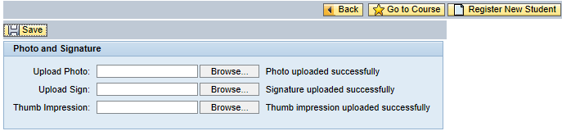
If upload is successful, system will display the successful message.
After uploading photo, signature and thumb impression, student master data input is completed.
Student Subject Booking:
Now user can proceed to student subject booking if desired by pressing “Next” button on the screen.
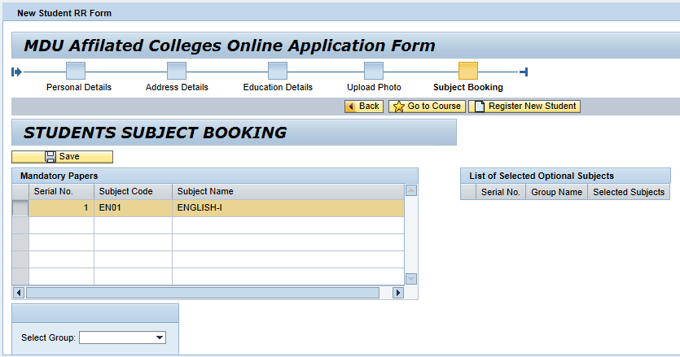
You are required to select the Subject Group (if existing). If groups are not existing, you can just click on button to save the mandatory subjects.
In case groups exist for a particular course and user is required book subjects belonging to group, he can select the corresponding available groups here.
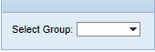
Users can have clear idea on status of student subject booking by the using the box in the screen.
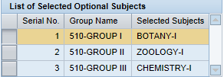
Once subject booking is done with all the desired groups, please click on to book selected subjects for the respective student.
Once data is saved successfully, system will intimate the user by a message.
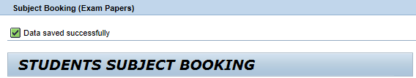
Now user have an option to either go to course or register another student for the same course/year/semester/quota.
To go to course, click on –
To create new student for the same course selection, click on -

Edit Student Master Data (RR)
Affiliated college users can edit their students who have been created by them for registration return process in the respective academic year and session.

This editing option is available only untill challan generation, once fee challan is generated student details will be locked and are available to view in display mode only. No editing permitted then after.

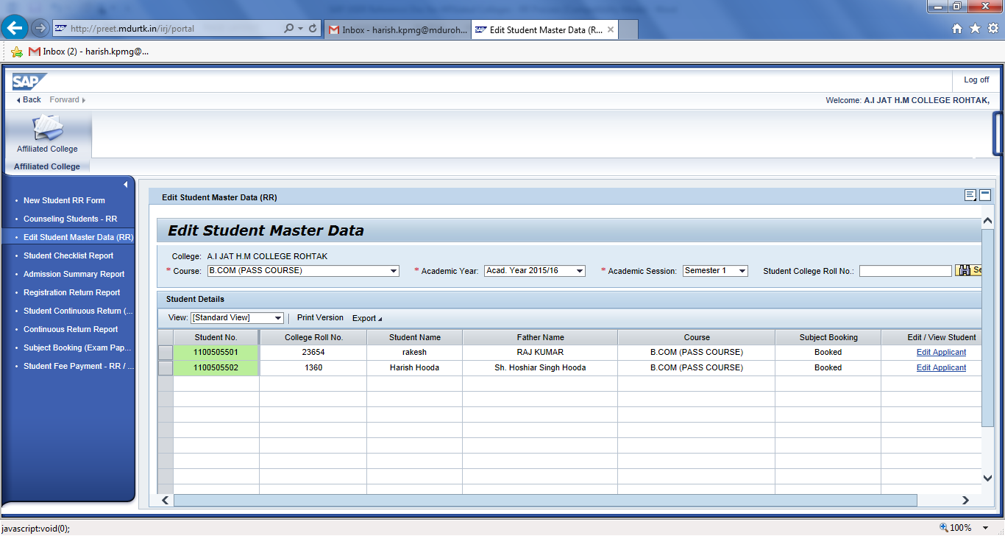
To search created students input Course, Academic Year, Semester and college roll number (optional) click on Search button below.
List of students will be coming and you can edit the desired student by click on “Edit Applicant” option.
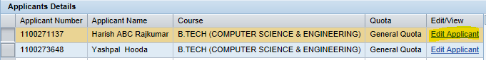
When you click on “Edit Applicant”
Course Detail:
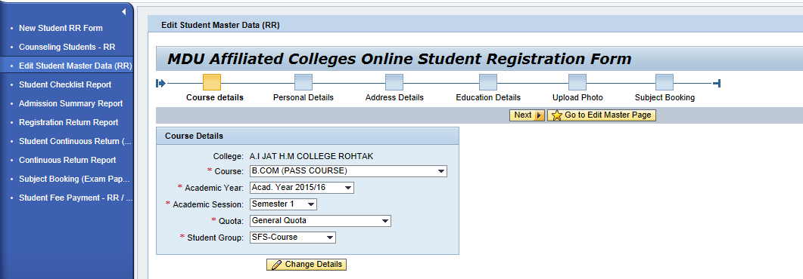
User can make necessary changes in this screen.

Personal Detail:
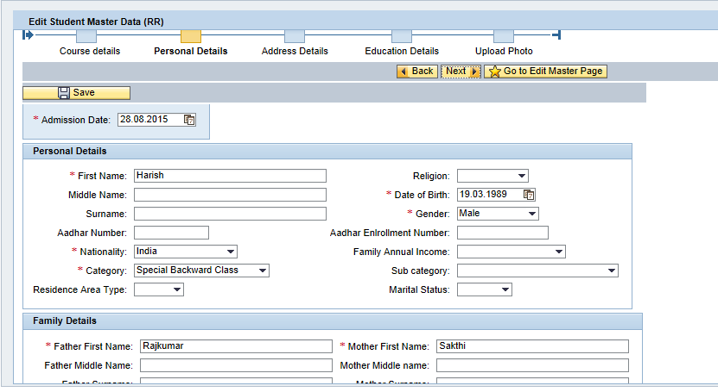
User can make necessary changes in this screen.

Address Details:
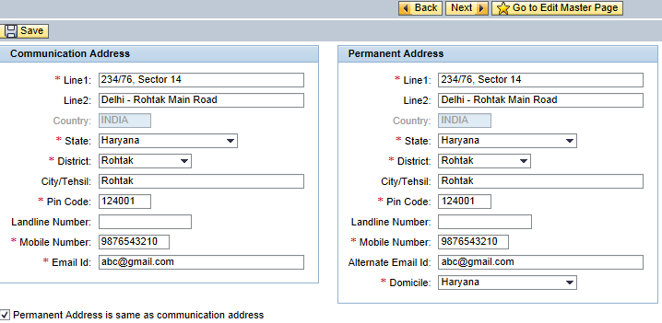
User can make necessary changes in this screen.

Educational Details:
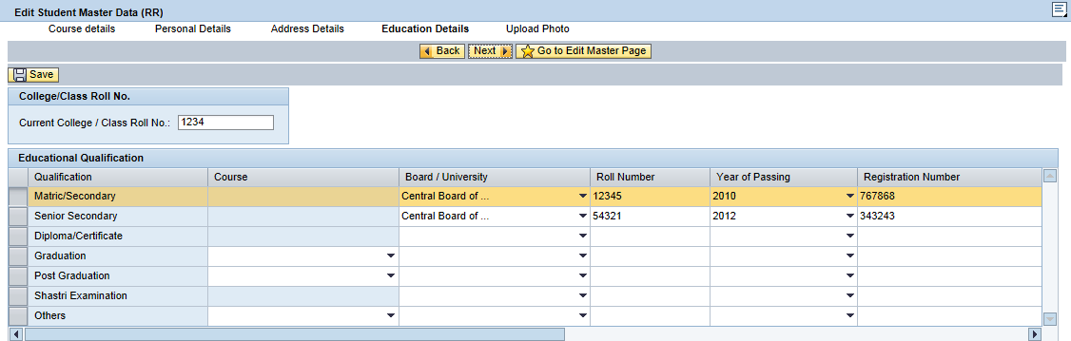

User can make necessary changes in this screen.
Photo, Signature and Thumb Impression:
You can upload photo, signature and thumb impression again and click on save to save the records.
After completing the editing activity, and to proceed for subject booking click on “Next” button.

Admission Summary Report

Admission summary report can be obtained by the college once fee is paid and subject booking is done for the respective students.
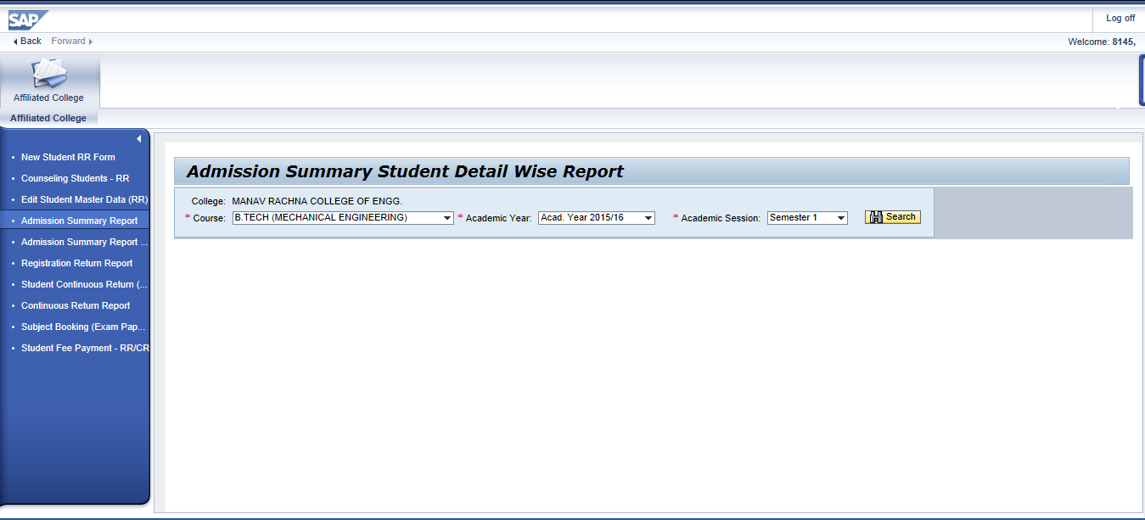
To obtain students is this report, college user should have got confirmation for the fees paid and subject booking should have been completed for those respective students.
Students for whom fees is not paid/confirmed or subject booking not done, will not be displayed in this report

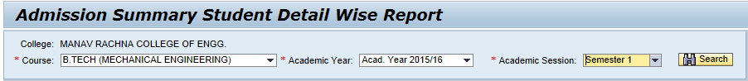
Select the desired values from the dropdown provided and click on button.
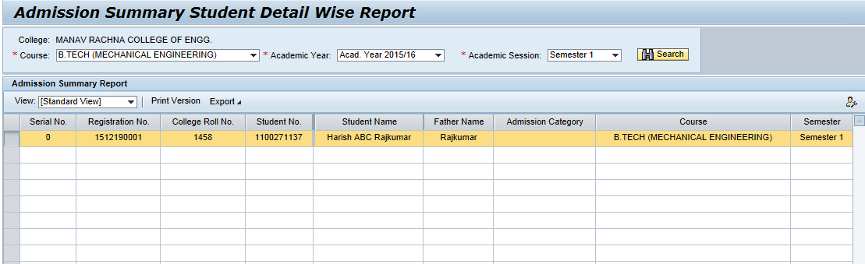

Students will be displayed accordingly.
For exporting the same to excel, click on and save the file to your computer.

Student Registration Report

Student Registration Report can be obtained by the college once fee is paid and subject booking is done for the respective students.
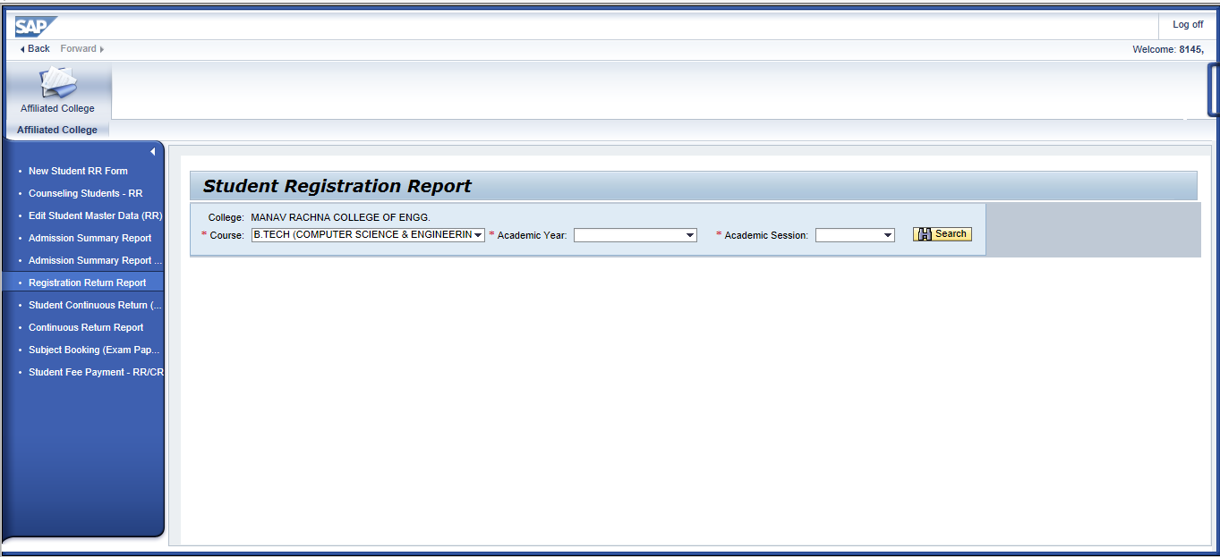
To obtain students is this report, college user should have got confirmation for the fees paid and subject booking should have been completed for those respective students.
Students for whom fees is not paid/confirmed or subject booking not done, will not be displayed in this report
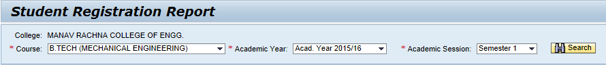
Select the desired values from the dropdown provided and click on button.
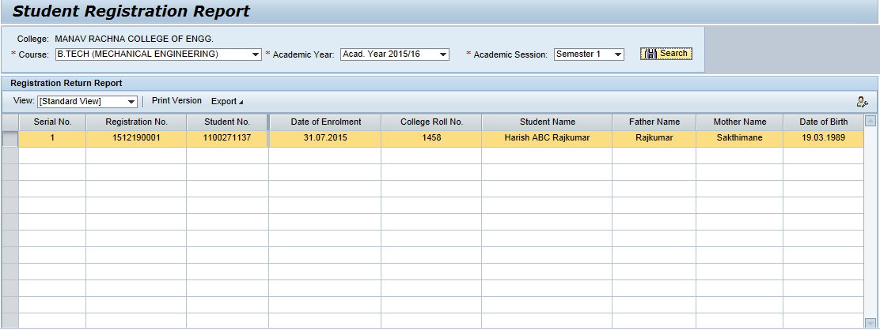
Students will be displayed accordingly.
For exporting the same to excel, click on and save the file to your computer.

