USER MANUAL DOCUMENT
MDU_SLCM_017 – Student Registration Program [Initial / Sessional]
DEVELOPMENT ID : ZMDU_SLcM_017
TRANSACTION CODE :
Selection Screen – Initial Registration
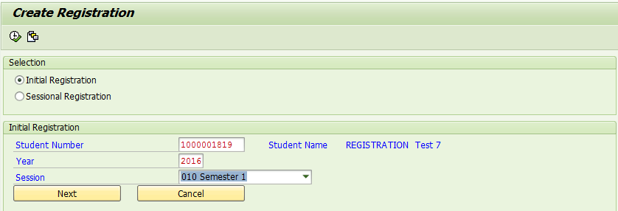
Select Initial Registration dropdown
Input desired values in selection screen
Click next
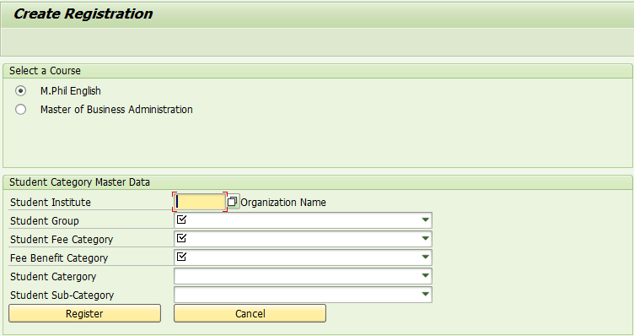
Here in this screen you are required to select the course for which student is seeking admission.
Along with the course, users are required to fill in certain master data like Student’s Institute, Student Group, Student Fee Category and Fee Benefit Category which are MANDATORY fields. These fields act as fee calculation base
Users can fill in Student Category and Student Sub-Category also if available.
Click Register
Incase QUOTA is not available, program will be returning an error message
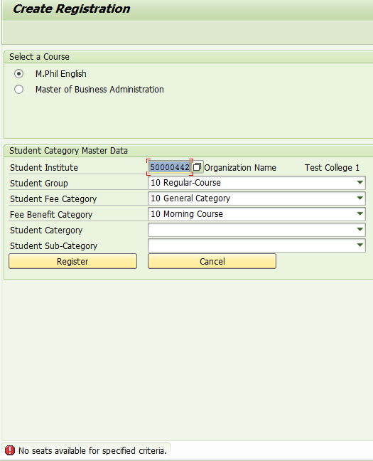
When quota is available for the selected criteria, then program would allow you for registering the selected student.
Program will give you a message stating successful registration and corresponding activities are:
* Registration Number will be generated for the student
* Quota will be updated accordingly
* “UNDER PROCESS” status tag will be assigned for the student
Selection Screen – Sessional Registration
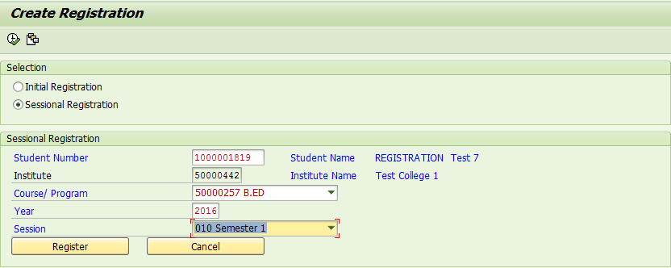
Select “Sessional Registration” in the selection screen
Input the desired details. Student’s institute would be popped automatically.
Click Register
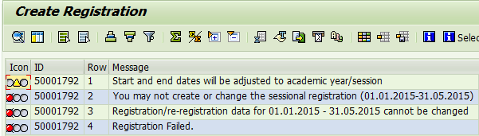
In case, you are trying to perform initial registration program will throw an error and will not proceed to registration
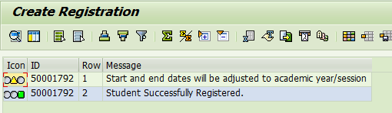
If all input is correct, program gives a message of successful registration.

